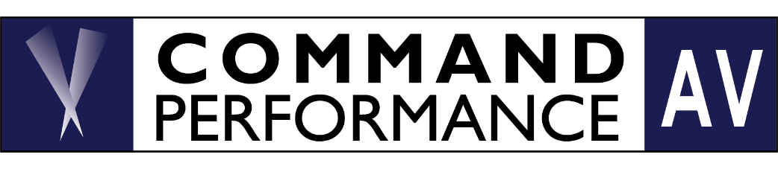
PRESS RELEASE
FOR IMMEDIATE RELEASE For More Information Contact
Jeffrey Fox
855-966-8225
jeff@commandav.com

“Let’s Dance!” Command performance Honors the ‘80’s with themed rooms at capital audiofest
--Audiovector Debut, Celebrity DJ and Special Events Distinguish Two Command Performance Rooms--
Rockville, MD –- November 8th, 2024: Command Performance AV, Virginia’s legendary High End Audio Salon celebrates “HiFi’s Greatest Decade” at Capital Audiofest 2024 with two rooms of products which honor the best technologies of the 1980s, featuring the music which made the era so memorable.
In the Democracy Room, Command Performance will feature the perfect homage to the 1980s: the Audiovector Trapeze Reimagined Loudspeaker, making its US Show Debut today at CAF. In celebration of their 45th Anniversary, Audiovector has authored a thoroughly modern reissue of their original loudspeaker, whose compact enclosure and compound-beveled baffle promise full-range, state-of-the-art performance in virtually any domestic environment. Notable Audio imports—J.Sikora Standard MAX Supreme Turntable, KV MAX Tonearm and Aidas Gold Mammoth Tusk LE Cartridge—provide cost-no-object analog playback at surprisingly reasonable prices while Nick Doshi’s EVOLUTION-series Monoblocks, Line Preamplifier and Phono Preamplifier bring pure-tube glory to this super system. And because the 1980s are particularly memorable for the Compact Disc, Nick Doshi will bring his 80’s-vintage Luxman DA07/DP07 DAC and Transport for shockingly analog-like CD Playback. REL 99 subwoofers will add the bottom end slam to the 1980s music. Cardas Clear Beyond cabling and HRS EXR-Series racking complete a modern-day super system guaranteed to flatter your favorite ‘80s tunes.
To celebrate the US Premiere of Audiovector Trapeze Reimagined, Command AV’s Democracy Room presentation will feature a nostalgic, 1980’s-themed experience extending beyond music to décor and fashion. On Friday, November 8th at 2 pm, Michael Fremer, Publisher of Tracking Angle and Editor-at-Large of The Absolute Sound, will serve as Guest DJ spinning that will make blow-dry your mullet, dust off your shoulder pads, and let the music take you back in time.
Command’s Room 305 room display delivers big-system sound at accessible prices, thanks to Gryphon’s Diablo 120 Integrated Amplifier. Sharing its DNA with Diablo 333, this entry-level Gryphon amplifier offers much of the performance of its big brother at smaller size and lower cost. Marten’s budget-friendly Oscar Duo Speakers are the ideal complement for Diablo 120: a gorgeous two-way stand-mount with serious bass impact and remarkable detail retrieval. The Oscar utilizes ceramic-coated aluminum drivers and sloped cabinets for exemplary phase- and frequency response. Aurender’s A15 music server will be feeding the Diablo 120’s built-in DAC while a SOTA Sapphire Turntable, Aidas Cartridge, and Sutherland TZ Vibe phono will handle analog. Transparent cables and Solid Tech Radius Rack complete this real-world, small room reference system.
About Command Performance AV: Industry veteran Jeff Fox founded Command Performance AV in 2007. Today, Command Performance is one of America’s finest Audio Salons, known as both for its superb expertise and product selection as well as its friendly, low-pressure atmosphere. Jeff was so impressed by the quality of emerging audio brands that he established Notable Audio Products as to bring components of exceptional value and performance to the US market. Both companies are headquartered in Falls Church, VA
Command Performance, 115 Park Avenue, #2, Falls Church, VA 22046 855-966-8225
www.commandav.com
www.notableaudio.com

